Using Knowledge Levels with AHA! for Discovering Interesting Relationships

Cristóbal Romero¹, Paul De Bra², Sebastián Ventura¹, Carlos de Castro¹

¹Departament of Computer Science and Numerical Analysis, University of Cordoba
14071 Campus de Rabanales, Cordoba, España
²Department of Computer Science,
Eindhoven University of Technology (TU/e)
PO Box 513, Eindhoven, The Netherlands

cromero@uco.es, sventura@uco.es, cdecastro@uco.es
debra@win.tue.nl

Abstract: In this paper we show how the AHA! system was (modified and) used to create an adaptive course in which the course material is presented in three levels of difficulty. The aim of the experiment is to perform data mining in order to find good candidates for meaningful relations between reading times, difficulty levels and test results. We want to discover information between all the stored evaluation data and show a selection to the teacher so that he can carry out appropriated modifications in order to improve the course.

Introduction

In the past years, we have seen an exponential growth in the use of web-based technology in distance learning systems. At the same time, more and more artificial intelligence techniques have been applied to these systems to improve students’ learning, named as Intelligent Tutoring Systems. The union of web-based learning with Intelligent Tutors has given place to the current Web-based Hypermedia Adaptive Systems that allow adapting the teaching to each individual student through Internet. But the methodology used for its construction is static. Once the construction of a course is concluded and it is published in the Web for its use, the system starts logging information about the users’ interaction with the course. However, teachers only use this information for student evaluation. We propose a dynamic construction methodology that uses the system usage information to discover some information that will allow the teacher to improve the course. We will use association rule mining to obtain useful information that helps the teacher to modify the course in order to improve student performance, thus making it educationally more effective (Zaïene, 2001). In order to prove our methodology we have developed some web-based hypermedia adaptive courses using the AHA! system (De Bra & Calvi, 1998). We have chosen AHA! because it is a simple general-purpose hypermedia adaptive system, it has a high degree of adaptation and it’s available in source code. We have modified AHA! in order to make it use different knowledge levels. In this way the AHA! engine can adapt the content and navigation of the course to the specific knowledge level of each student. Another advantage of AHA! is that it automatically stores usage information in logs files. We converted these files to a database in order to do association rule mining.

AHA! with knowledge levels

AHA! is a general architecture for building adaptive hypermedia applications. We have modified it in order to be able to control the adaptation depending on the student’s knowledge level. To do it, we have modified: the user model, the domain model and the adaptation engine, see [Figure 1].
- Domain Model. One course consists of several chapters with several concepts, but the concepts and the questions related with these concepts are divided in three levels of difficulty (high, medium or low).
- User Model. The student’s knowledge for each concept, initial test or final test can be only one of these values: 0 (not yet read), 10 (low), 50 (medium) and 100 (high).
- Adaptation engine. Before studying a new chapter the students have to do an initial adaptive test to discover their initial knowledge level. The system then presents them only the concepts with this level. Each concept has an activity to evaluate the student’s knowledge about this specific concept. When the students have visited all the concepts they have to do a final (multiple-choice) test to evaluate the their knowledge about the chapter at this level. If they obtain a medium or high level in the final test they can go to a higher level. If they are in the highest level already they can go to the next chapter. In each chapter everything starts again: initial test, studying pages and doing activities and then the final test.

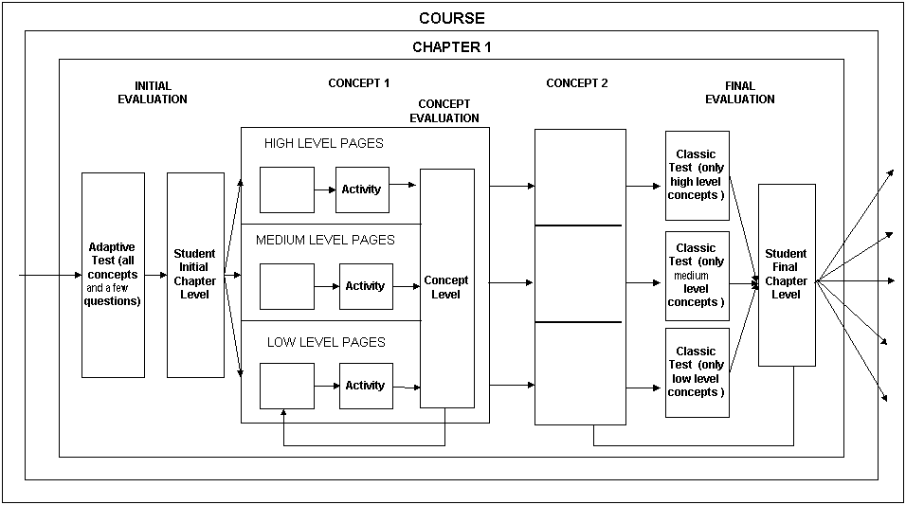
Figure 1: Modified AHA adaptation engine.

Discovering association rules and Conclusions

We are using a genetic algorithm to obtain association rules (Romero et al., 2002) from the user evaluation data. The association rules relate variable values. Genetic algorithms are a paradigm based on the Darwin evolution process, where each individual codifies a solution and evolves to a better individual by means of genetic operators (mutation and crossover). In general the main motivation for using genetic algorithms for rule discovery is that they perform a global search and cope better with attribute interaction than greedy rule algorithms often used in data mining. The format of the rules we want to discover is:

IF Variable1 = Value1 (AND Variable2 = Value2 …) THEN VariableX =ValueX
Where:
- Variable1, Variable2, VariableX are the database’s field names (times, levels and scores).
- Value1, Value2, ValueX are the values of the corresponding database fields.

We want to discover relations between knowledge levels, times and scores that help the teacher modify the course’s original structure (joining concepts, changing concepts from level or chapter, etc.) and content (eliminating or improving bad questions, bad pages, etc.). We have developed a course on Linux with the modified AHA! and we are now obtaining usage information about different types of students with different initial knowledge about Linux. We expect to have enough usage information in a few months to apply association rule mining and see how useful the discovered relations are. We have tested our genetic algorithms with the data obtained from the evaluation of a Web-based Hypermedia Course on the subject of Rheumatology (Romero et al., 2002) and we showed that they can produce potentially useful results. We are also developing a more sophisticated evolutionary algorithm to obtain more comprehensible and interesting rules.

References

De Bra, P. and Calvi, L. (1998). AHA! An open Adaptive Hypermedia Architecture, The New Review of Hypermedia and Multimedia, vol. 4, pp. 115-139, Taylor Graham Publishers.
Romero, C., De Castro, C., Ventura, S. (2002). Using Genetic Algorithms for Data Mining in Web-based Educational Hypermedia System. Workshop on Adaptive Systems for Web-based Education. Málaga, Spain.
Osmar R. Zaïene. (2001). Web Usage Mining for a Better Web-Based Learning Environment. Proc. of Conference on Advanced Technology for Education. Alberta, Canada.

